Assignment- 4
Student Name : BHAGAVATHY M
Student Roll Number 2019504012
Maximum Marks: 2 Marks
Question: 1. Write code and connections in wokwi for ultrasonic sensor. Whenever the distance is less than 100 cms send “alert” to IBM cloud and display in the device recent events.
Solution: WOKWI SHARE LINK:
https://wokwi.com/projects/347603236138517074
IBM CLOUD IMAGE:
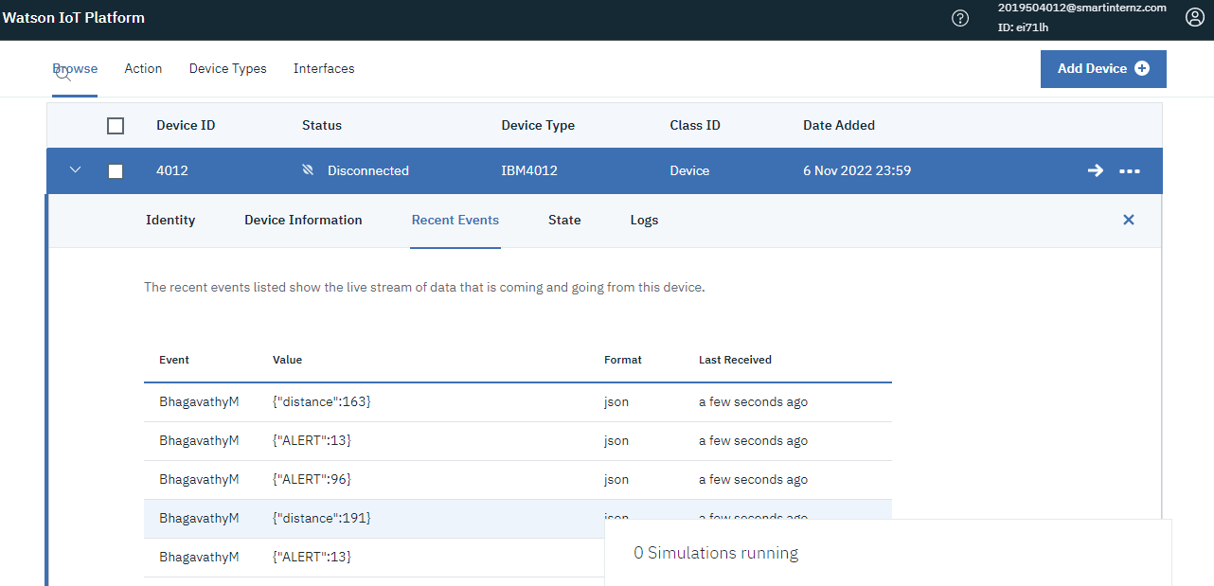

SIMULATION IMAGE:
LED ON:
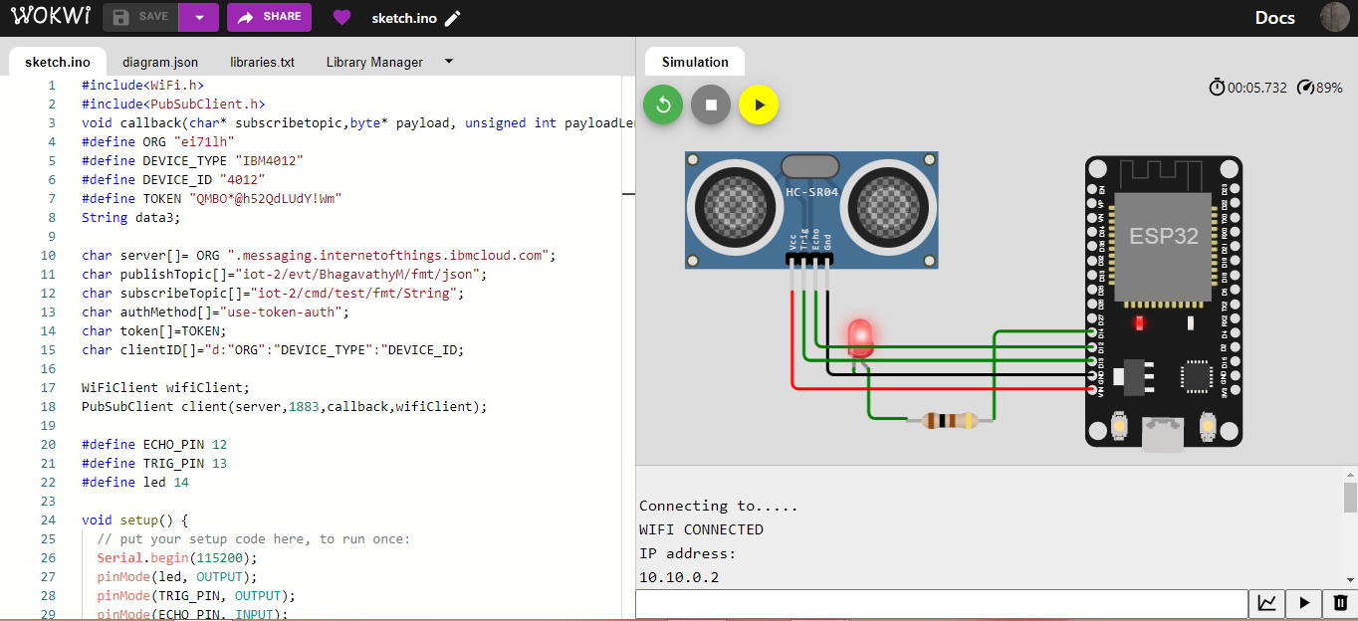
LED OFF:
